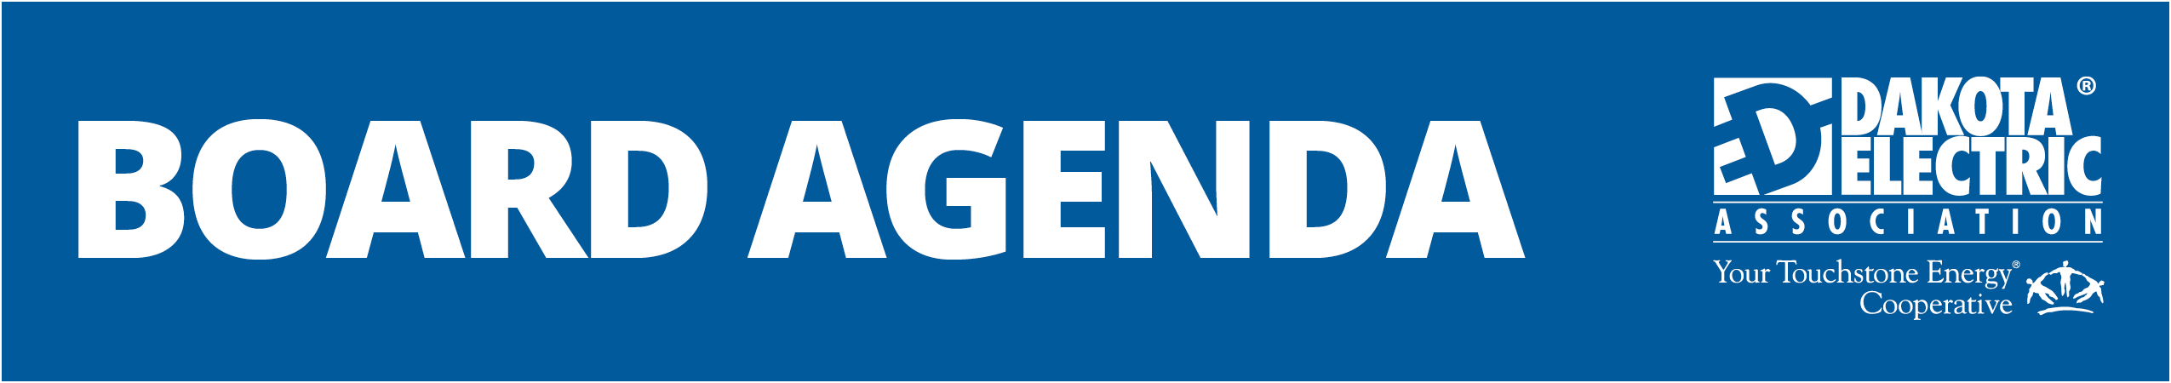

August 22, 2024, Board of Directors Meeting

TIME ALLOCATED | OBJECTIVE | RESPONSIBILITY
8:30 a.m. to 8:35 a.m. | Call to Order  Pledge of Allegiance  Approval of Agenda  Member Comments | Paul Bakken
8:35 a.m. to 8:40 a.m. | Consent agenda  - July 25th, 2024, Board Meeting Minutes  - July 2024 Board Legal Fees  - Updated May 23rd, 2024, Board Meeting Minutes  - 2023 Charitable Organization Annual Report Form – Resolution 24-8-1 | Paul Bakken
8:40 a.m. to 9:25 a.m. | Executive Session  - Union Negotiations Update | Betty Jo Kiesow
9:25 a.m. to 10:00 a.m. | Executive Session  - Rate Case Process Update | Adam Heinen
10:00 a.m. to 10:15 a.m. | Recess
10:15 a.m. to 10:45 a.m. | Employee Engagement Survey | Trina Sandlie
10:45 a.m. to 11:30 a.m. | CEO Report | Ryan Hentges
11:30 a.m. to 11:45 p.m. | Great River Energy Report | Bill Middlecamp  Margaret Schreiner
11:45 a.m. to 12:15 a.m. | Lunch
12:15 p.m. to 12:25 p.m. | MREA Report | John DeYoe
12:25 p.m. to 12:30 p.m. | Attorney Report | Steve Yoch
12:30 p.m. to 12:40 p.m. | Audit Committee Update | Committee Chair
12:40 p.m. to 12:50 p.m. | Unclaimed Capital Credits Committee Update | Committee Chair
12:50 p.m. | Adjournment
Resource Materials
- Monthly Financial Statements
- Community Activities Report
- Donations Listing
- August MREA Board Notes

